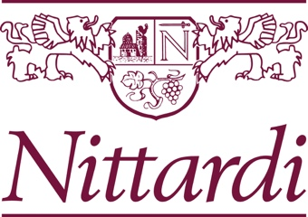

PREMIO NITTARDI

Application for the competition for the creation of the label and wrapping paper of the 40th vintage of Casanuova di Nittardi 2020 Chianti Classico. Please send the completed form along with high quality images of the two works and a full CV to premio@nittardi.com until the 03.07.2022.

Name ___________________________________________________________________________

Address _________________________________________________________________________

E-Mail and telephone ______________________________________________________________

Title, format, technique of the artworks for the label and wrapping paper ________________________________________________________________________________

Website or social-media ________________________________________________________________________________________________________________________________________________________________

Short Resume

_ I confirm that I read the conditions to participate and agree with them.

_____________________
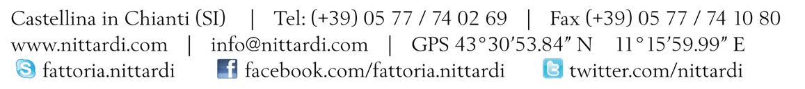
City, Date and Signature

